Case 15-Indo-Timor-Ancestral Figurines

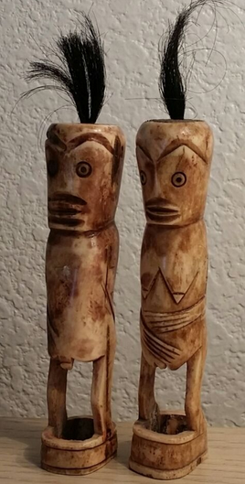 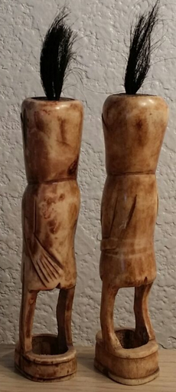 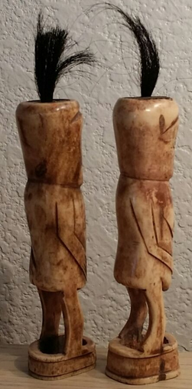

Timor Island, Indonesia, Buffalo Bone Scrimshaw Fertility Figures

Formal Label: Indo-Timor Island-Ancestral Male and Female Figures-Buffalo Bone Scrimshaw-Early 1900’s

Accession Number:

Display Description:

This pair of hand etched and hand carved buffalo bone scrimshaw fertility figures are part of Tetum shamanic paraphernalia from the Tetum people of Timor, Indonesia (previously Timor-Leste or East Timor) who numbered more than 300,000 in 2000. These figures were carved in the early 20th century by a local village shaman or Matan Do’ok (“far-seeing-eye” in the Tetum Malayo-Polynesian language) from a village 15 km west of the city of Viqueque. The village shaman is dedicated to maintaining a balance of male-female harmony in his area of social responsibility. These figurines represent the visible part of the ceremony he conducts with newly married couples that involves their understanding their positive (male) and negative (female) energies both sexual and social and how to maintain a healthy balance between them. The shaman gives the opposite sex of each of these figurines to a newly married couple as a ritual wedding offering. To further impress the couple with their mutual responsibilities as part of a marriage alliance he impresses them with the rôle of the ancestors in overseeing this alliance and so each figurine is implanted with the symbol of the ancestors, the water buffalo’s presence in the form of its hair, for the buffalo is the power of Tetum unity between the descendants and their ancestors: the water buffalo is the symbol of continuing prosperity and peace in the village. The tuff of black buffalo hair on top of the head of each effigy represents this protective omniscience of the ancestors.

Continuing this theme of conjoining opposite energies in productive ways, both men and women enact distinctive and important parts in agricultural rituals. Fields are sown around a corn shrine. Women represent the sacred world and men the secular/ Once again the Tetum observe complex rites that are meant to join the sacred and secular worlds, thus ensuring a good harvest. Religious shamans, female and male, act as interpreters of the omniscient ancestral spirits in meditations they undergo with the entire village, thus communicating this power to all.

Date or Time Horizon: Early 1900’s

Geographical Area: East Timor, village 5 km west of Viqueque

Map:

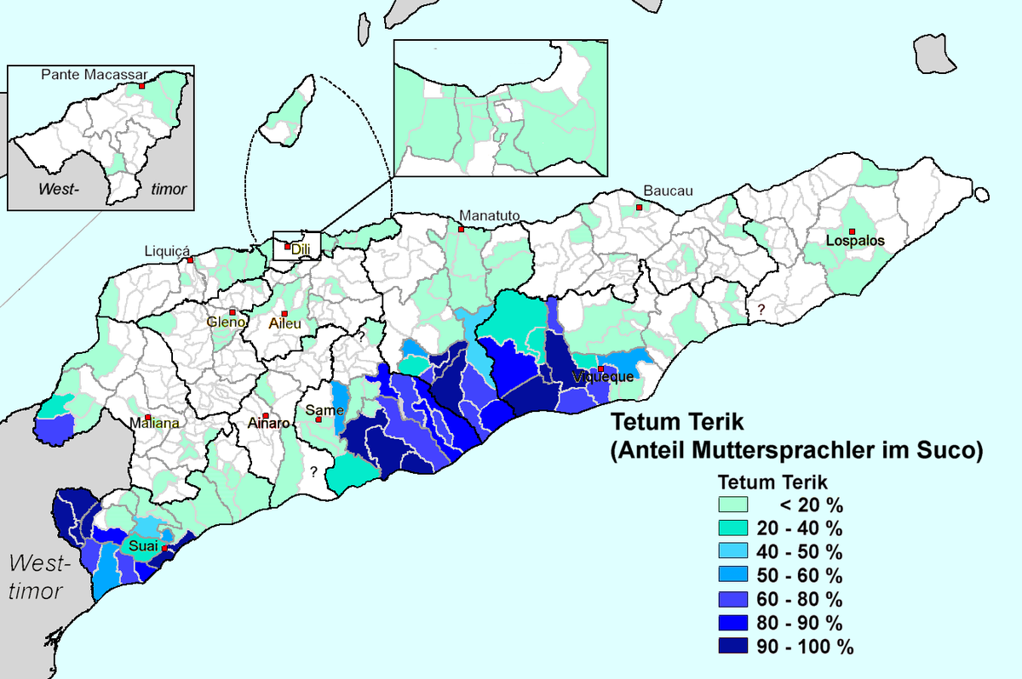

https://upload.wikimedia.org/wikipedia/commons/thumb/b/b0/Tetum_Terik.png/1200px-Tetum_Terik.png

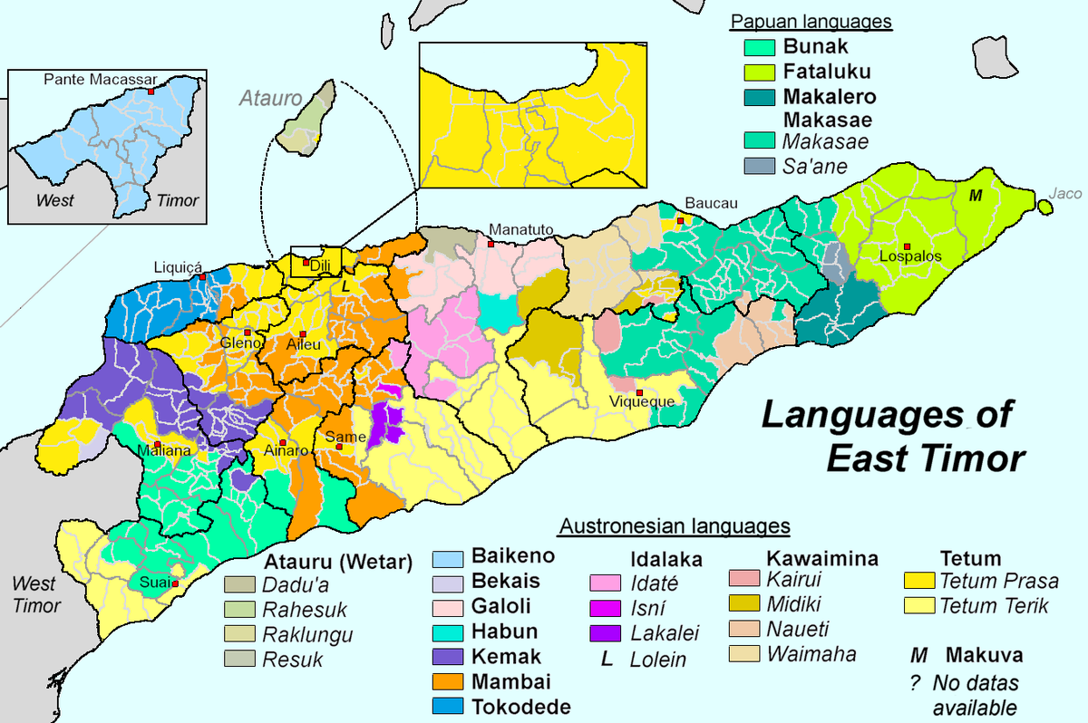

https://upload.wikimedia.org/wikipedia/commons/thumb/d/d9/Sprachen_Osttimors-en.png/1200px-Sprachen_Osttimors-en.pngGPS:

Cultural Affiliation: Tetum

Medium: Buffalo bone

Dimensions: ­­­­

Weight:

Provenance: East Timor, 1965

Condition: original

Discussion:

References:

Hicks, David. 2004. *Tetum Ghosts and Kin: Fertility and Gender in East Timor*, Second Edition. Longrove, IL: Waveland Press Inc.

